Network IP: 13.189.106.0

Mask: 255.255.254.0 /23

X = 32 – 23 = 9 => 2^9 IPs = 512 IPs

**Given sub networks**

N1: 120 IPs

N2: 104 IPs

N3: 40 IPs

N4: 40 IPs

N5: 8 IPs

**Other sub networks**

N1345: 4 IPs

N12: 2 IPs

N5w: 2 IPs

**N devices (IP) + 1 router + 1 NA + 1 BA => n + 3 required IPs for N1,N2,N3,N4,N5**

N1: 120 + 3 = 123 IPs <= 128 = 2^7 /25

N2: 104 + 3 = 107 IPs <= 128 = 2^7 /25

N3: 40 + 3 = 43 IPs <= 64 = 2^6 /26

N4: 40 + 3 = 43 IPs <= 64 = 2^6 /26

N5: 8 + 3 = 11 IPs <= 16 = 2^4 /28

**For sub networks N1234, N15 and N5w we need only 2 extra IPs**

N1345: 4 + 2 = 6 IPs <= 8 = 2^3 /29

N12: 2 + 2 = 4 <= 4 = 2^2 /30

N5w: 2 + 2 = 4 <= 4 = 2^2 /30

**Total IPs**

128 + 128 + 64 + 64 + 16 + 8 + 4 + 4 = 416 < 512

N1=128, N2=128, N3=64, N4=64, N5=16, N1345=8, N12=4, N5w=4

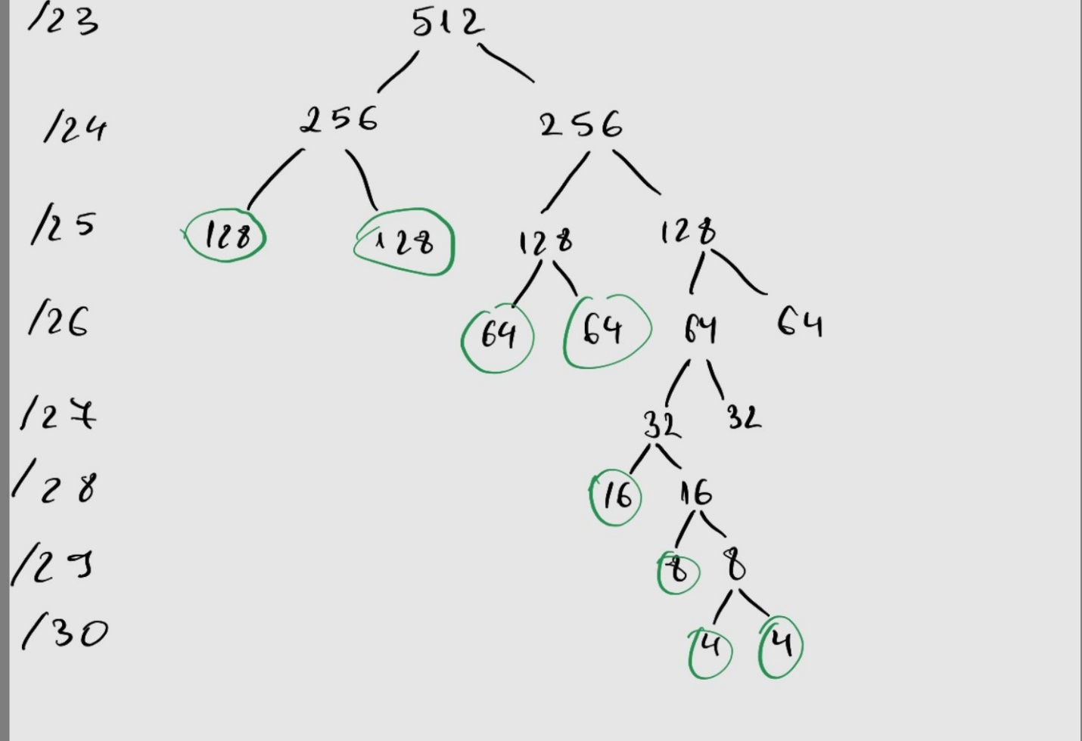

Recursive network split using intervals

13.189.106.0 /23

[0………………………………………………………………………………………………………………………………………………………512]

[0………………255][256…………………………………………………………………………………………………………………………512]

[0….127][128…255][256……………383][384……………….…………………………………………..……………………………512]

[0….127][128…255][256…319][320………383][384………………………………………………..……………………………512]

[0….127][128…255][256…319][320………383][384……………447][448……………………..……………………………512]

[0….127][128…255][256…319][320………383][384…..…415][416………447][448.……………………………….…512]

[0….127][128…255][256…319][320………383][384….399][400.…415][416………447][44…………………….…512]

[0….127][128…255][256…319][320………383][384….399][400.…407][408…..415][416………447][44……512]

[0….127][128…255][256…319][320………383][384….399][400.…407][408….411][412...415][416………447][44……512]

Enumerating the networks

N1 = 13.189.106.0/25 R1=.1, DHCP server = .2

N2 = 13.189.106.128/25 R2=.129, WEB server = .130

N3 = 13.189.107.0/26 R3=.1, DNS server = .2

N4 = 13.189.107.64/26 R4=.65

N5 = 13.189.107.128/28 R5=.129

N1345 = 13.189.107.144/29 R1=.145, R3=.146, R4 =.147, R5=.148

N12 = 13.189.107.152/30 R1=.153, R2=.154

N5W = 13.189.107.156/30 R5=.157, Rw =.158